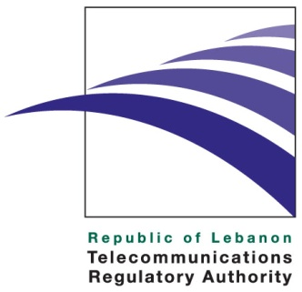

Press Release

October 28th 2009
The 9th Global Symposium for Regulators (GSR)



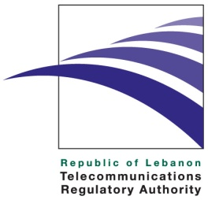

The 9th Global Symposium for Regulators (GSR) to be held for the first time in Beirut
“Hands-on or Hands-off?” Stimulating growth through effective ICT regulation.

Beirut, October 28th, 2009: A press conference was held today at the Habtoor Grand Hotel (Hamra Room) in the presence of local, regional and international media to announce the hosting the “9th Global Symposium for Regulators” (GSR) conference in Lebanon. Scheduled from Nov 9th to 12th 2009, this event will not only help Lebanon reclaim a leadership position on the international telecommunications scene, but it will also attract investor interest in Lebanon and help unleash the potential of telecommunications as a driver of growth and competitiveness of the Lebanese economy. GSR will be held under the High Patronage of His Excellency the President of the Republic of Lebanon, General Michel Sleiman. It is jointly organized by the Telecommunication Development Bureau (BDT) of the International Telecommunication Union (ITU), and the Telecommunications Regulatory Authority of Lebanon (TRA). GSR is an international conference that will bring together heads of national regulatory authorities from both developed and developing countries to share views and experiences and discuss key strategic topics facing the telecommunications sector in this global venue.

According to Dr. Shehadi, Chairman and CEO of the Telecommunications Regulatory Authority (TRA), telecommunications can become Lebanon’s engine for economic growth, job-creation, and a driver of productivity and competitiveness for Lebanese businesses. Accordingly, this conference comes at a very critical time as TRA, an independent authority established in 2007, strives to meet these goals and pave the way for a regulatory environment that fosters a competitive telecommunications market to deliver state-of-the-art services at affordable prices to the broadest spectrum of the Lebanese population.

In the last two years, TRA has made the fastest progress in a very short time span through the liberalizing of the telecommunications market and is poised to launch a large scale liberalization of mobile and broadband services in 2010. During 2008 and 2009, the Authority had carried out more than 21 public consultations on new regulations, policies, and decisions, signed a Memorandum of Understanding with the Ministry of Economy and Trade on February the 11th, 2009 to promote consumer protection, and built an innovative broadband roadmap to liberalize the market for key telecommunications services, namely mobile, broadband, and international.

The GSR event, in parallel with TRA’s mission in promoting growth in the telecommunications sector, will highlight the new challenges that regulators should overcome, while focusing on the impact of the financial crisis on regulation. In addition, it will shed light on the importance of consumer protection and analyze key issues such as interconnection, mobile regulation and VOIP- all of which are factors that will provide Lebanon with an opportunity to leap-frog and reclaim its leading position in telecommunications in the region.

This event provides an opportunity for all regulators to work closely together and learn from one another to overcome challenges which are global in nature such as harmonization of radio frequencies, Green ICT, or universal service … among others.

The GSR event titled “Hands-on or Hands-off? Stimulating growth through effective ICT regulation” will be held at the Habtoor Grand Hotel Convention Center in Beirut.

In addition, the 2nd Global Industry Leaders Forum ( GILF) chaired by Dr. Saad Al Barrak, Zain’s CEO, will take place on the very first day of the event (November 9th ). GILF has been designed to complement and reinforce the GSR and aims at facilitating the dialogue between industry and policy makers and regulators on pertinent issues that currently prevent or slower down ICT and telecommunication investment in developing and least developed countries. All participants in the GILF are invited to attend the first day of the GSR.

The two events come in response to Resolution 29 of The World Telecommunication Development Conference (WTDC-06) in Doha, which stipulates ITU Telecommunication Development Sector initiatives on sector member issues, and in accordance to the recommendations of the ITU Telecommunication Development Advisory Group (TDAG ’07) meeting held in Geneva. These two conferences are organized by ITU to bring together ITU members – regulators and sector members (private sector operators)- and is not an ITU statutory conference (i.e., required by the ITU Convention) where binding decisions are taken and where governments members of ITU are expected to represent their country and vote.

For more info, please contact Ms. Sarah Fayad IFP at 05- 959 111 Ext: 325, or Ms. Adele Saab TRA at 01-964 300 ext: 1104.

About the TRA

The TRA is an independent public institution assigned to liberalize, regulate, and develop the telecommunications sector in Lebanon. Established by Law 431 of 2002, the TRA effectively started operations upon the nomination of its board members in February 2007.

The TRA duties and powers include, among other areas, protecting consumers’ rights, licenses and regulations, managing radio spectrum and the overall numbering plan, monitoring the market for any abuse of dominant market power and anti-competitive practices, as well as taking remedial steps when needed and promoting effective and fair competition among existing and new licensed operators. More information regarding the TRA can be viewed at http://www.tra.gov.lb

Media Contact: media@tra.gov.lb

