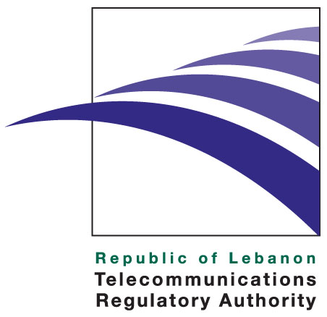

Press release

February 5, 2013

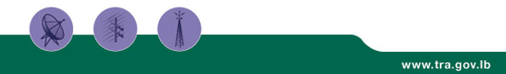

The TRA celebrates the Safer Internet Day 2013

The Internet has become part of our children’s world today – they are ‘growing up digital’, with technology embedded in every aspect of their lives. Children are vulnerable, and the cyberspace that they surf in daily should be safe. When accessing the Internet, children could be targets of pedophiles, cyber bandits, hackers and online predators. Adults need to be aware of the many available options to secure their Internet at home. They also need to understand the potential risk areas and be able to educate their children to act responsibly online.

Since its inception, the Telecommunications Regulatory Authority considered Internet Safety as one of its priority work axis. The Authority organized various workshops, projects and activities that evolve around finding solutions that suit best the Lebanese community regarding children online protection. The TRA was also deeply involved in the organization of the Safer Internet Day (SID), an international yearly event that takes place regularly in February to promote safer and more responsible use of online technology and mobile phones, especially amongst children and young people across the world.

Safer Internet Day 2013 is the tenth edition of the event. It took place on Tuesday 5 February 2013 under the theme ‘Online rights and responsibilities', where users are encouraged to 'Connect with respect'. This year’s edition involved the launch of a new school curriculum on online safety, a competition between school students, a theatrical play dedicated for online safety on February 9 at the Unesco Palace as well as a strong media campaign to support the cause.

For many years, Lebanese stakeholders have been actively participating in this event which has been steadily growing, with an increase in general awareness, stronger involvement of relevant stakeholders in the field of Internet safety and a high level of media interest. This year, World Vision, the Telecommunication Regulatory Authority (TRA), the Higher Council for Child Protection at the Ministry of Social Affairs, the Center for Educational Research and Development at the Ministry of Education and Higher Education, Himaya, YMCA and many others, worked together to create safety awareness and responsible use of the Internet.

In line with the event and the importance of protecting children online, several projects have been initiated and developed by the TRA:

- A new national safety website targeting the Lebanese community www.e-aman.com . This website, aims at helping Lebanese citizens become more responsible in the cyberspace. It offers comprehensive tips and exhaustive information for parents, youngsters and teachers and helps them bypass Internet risks.

- Two Facebook pages «National Internet Safety Lebanon» and « Safer Internet Day Lebanon » have been created to increase awareness about the subject

- A Twitter and a Hash account were set for the event @SIDLebanon Hashtag: #SIDLB13

- Various interviews on local radios and TVs were conducted

- Over 3 million SMS were sent during the week of February 5th to mobile subscribers on their mobile phone directing them to www.e-aman.com

The TRA is committed to protect children online and has also taken various measures outside this event to protect children in the cyberspace, mainly by:

- Providing parents with monitoring tools to protect their children while surfing the Internet (Parent/child binding contracts distributed in various schools, an informative section on the TRA website dedicated to parents, devoted parents training through schools…)
- Making various contributions to local, regional and international conferences (Arab IGF, Escwa, MOT, ISOC, Unesco…), Lebanese schools (Grand Lycee Franco-Libanais, Saint Charles School), and workshops dedicated to all aspects of online child protection in Lebanon.
- Coordinating various stakeholders’ efforts around legislative, technical, and regulatory issues (Ministry of Social Affairs, Ministry of Interior, all Lebanese ISP’s, major NGO’s….)
- Conducting a study within its prerogative as a member of AREGNET (Arab Network of Regulators) amongst all Arab countries about the subject. Following the survey, a draft Code of Practice for Internet service Providers was prepared and is ready to be shared amongst all AREGNET members soon.
- Taking measures towards influencing Internet Service Providers and Internet Cafes to take actions towards ensuring a safe cyberspace for children.

About the TRA
The TRA is an independent public institution assigned to liberalize, regulate, and develop the telecommunications sector in Lebanon. Established by Law 431 of 2002, the TRA effectively started operations upon the nomination of its board members in February 2007.

The TRA duties and powers include, among other areas, protecting consumers’ rights, licenses and regulations, managing radio spectrum and the overall numbering plan, monitoring the market for any abuse of dominant market power and anti-competitive practices, as well as taking remedial steps when needed and promoting effective and fair competition among existing and new licensed operators. More information regarding the TRA can be viewed at http://www.tra.gov.lb

Media Contact: media@tra.gov.lb

