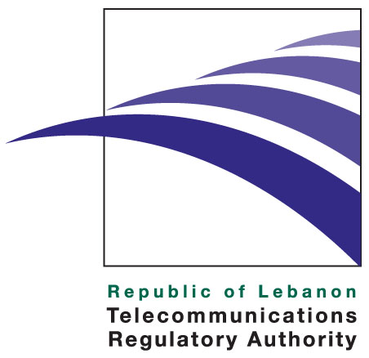

Press release

June 22, 2011



TRA Senior Experts expose Dangers that Children face online and in Cyber Cafes at UNESCO Palace

TRA Senior Experts represented the TRA on June 17th and 20th at the "Quality Assured Outcomes in all Lebanese Schools" project held at UNESCO by Mr. Taan Chaib, Chairman of “the Excellence in Learning and Leadership Foundation” (ELLF), where they summarized the TRA actions related to child safety and protection while using the Internet and in cybercafes.
TRA Quality of Service Management Expert, Mr. Said Haidar gave a presentation entitled “The Role of parents and academic institutions in protecting children in cyberspace”, followed by a panel discussion where interesting topics were discussed by education leaders and teachers concerning a unified vision on children protection and the importance of public awareness at the level of parents, schools and students as a strategic resolution method.
TRA Senior Consumer Affairs Expert, Mrs. Corine Feghaly elaborated on the TRA’s children protection project, which encompasses a kit destined to private and public schools in Lebanon that includes security guidelines, binding contracts and awareness information among others, in cooperation with key stakeholders such as ELLF and UNESCO.

Dr. Wafa Bou Diab, Quality Control Expert at the TRA gave a presentation entitled "Towards Child-Friendly Internet Cafes" where she explained the risks that children are exposed to while surfing the Internet in cyber cafes. Dr. Bou Diab show-cased a benchmark of efforts deployed in other countries to regulate the cyber café businesses. She also reviewed potential solutions that need to be implemented to protect children browsing the Internet in public places. [IYH] Her presentation was followed by questions and answers, where various interesting topics were raised.

In its continuous efforts to protect children online, the TRA salutes the latest efforts of the Ministry of Telecommunications (MOT) to provide free internet access in public gardens and parks in Lebanon and recommends that the parental control safety features be implemented on all internet connections provided by the Internet Service Providers (ISPs) for these locations, in order to make sure that no illicit sites be accessible by children visiting the gardens.

About the TRA
The TRA is an independent public institution assigned to liberalize, regulate, and develop the telecommunications sector in Lebanon. Established by Law 431 of 2002, the TRA effectively started operations upon the nomination of its board members in February 2007.

The TRA duties and powers include, among other areas, protecting consumers’ rights, licenses and regulations, managing radio spectrum and the overall numbering plan, monitoring the market for any abuse of dominant market power and anti-competitive practices, as well as taking remedial steps when needed and promoting effective and fair competition among existing and new licensed operators. More information regarding the TRA can be viewed at http://www.tra.gov.lb

Media Contact: media@tra.gov.lb

