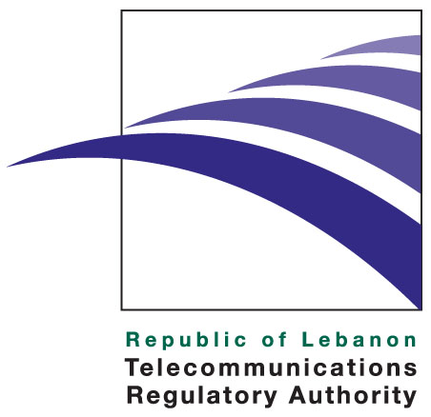

Press release

October 14, 2010

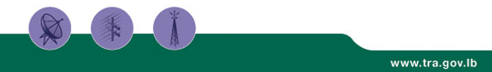

Euro-Mediterranean Telecom Experts meet in Beirut to discuss independence of Regulatory Authorities for electronic communications.

The Telecommunications Regulatory Authority of Lebanon and the European Union host on October 19th and 20th the conference aiming at shedding light on the benefits of the establishment of independent Regulatory Authorities.

The Telecommunications Regulatory Authority of Lebanon and the European Union funded program New Approaches for Telecommunications Policy-3 (NATP-3) will be hosting a Euro-Mediterranean Regulators Group (EMERG) conference titled “Independent Regulatory Authorities” on October 19th and 20th, 2010 at the Movenpick Resort in Beirut. The Euro-Mediterranean Regulators Group (EMERG) was established in 2008 with EU support as an informal platform for cooperation. EMERG is organizing this meeting in recognition of the successful establishment of the Telecommunications Regulatory Authority (TRA) in Lebanon, and in support of the plans of the Syrian and Palestinian Telecommunications Ministers to adopt a similar approach.

This event aims at examining the type of independency that Regulatory Authorities should enjoy and at shedding light on the benefits of such independent institutions. Through professional and non-political application of regulations and dispute resolution, the independence of Regulatory Authorities enhances investors' confidence in the Telecommunications sector. Lebanon joined this approach by establishing the TRA in 2007 as per Law 431/2002. Syrian and Palestinian Authorities are in the process of preparations to follow suit.

This conference will be marked by the participation of HE Dr. Charbel Nahas, Minister of Telecommunications of Lebanon, HE Mashhour Abou Daqqa Minister of Telecommunications and Information Technology of the Palestinian Authority, the deputy Telecommunications Minister of Syria Dr. Bassel Alkeschi, Mrs. Cecile Abadie, Chargée d’Affaires at the Delegation of the European Union to Lebanon, the Chairman of EMERG Dr. Mountassir Billah from Morocco and the Vice-Chairman of BEREC Mr. Chris Fonteyn (the new EU institute of regulators). The Chairman and Board Members of Lebanese TRA, Dr. Imad Hoballah, Mr. Patrick Eid and Mrs. Mahassen Ajam, as well as the Board of the Regulatory Authorities participating in EMERG will be actively participating. Speakers and participants from the Industry, Civil Society and the Media have been invited to join in the debate.

The first day of the conference, October 19th will be focusing on the 'political' aspect of the debate where the merits of independence, the new institutional developments in the EU and the experiences in the region will be tackled. The second day, October 20th will be a closed group discussion among Euro-Mediterranean Regulators where the details of independence through the example of the youngest EMERG member - the Lebanese TRA- will be examined.

About the TRA
The TRA is an independent public institution assigned to liberalize, regulate, and develop the telecommunications sector in Lebanon. Established by Law 431 of 2002, the TRA effectively started operations upon the nomination of its board members in February 2007.

The TRA duties and powers include, among other areas, protecting consumers’ rights, licenses and regulations, managing radio spectrum and the overall numbering plan, monitoring the market for any abuse of dominant market power and anti-competitive practices, as well as taking remedial steps when needed and promoting effective and fair competition among existing and new licensed operators. More information regarding the TRA can be viewed at http://www.tra.gov.lb

Media Contact: media@tra.gov.lb

