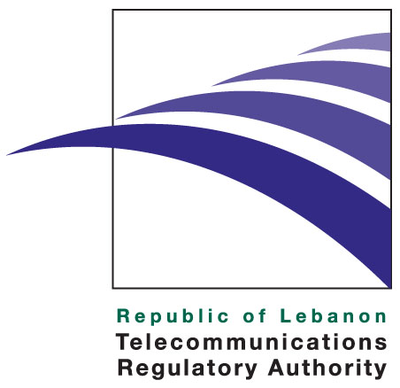

Press release

December 1, 2009

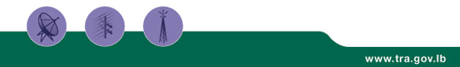

The TRA issues three interim licenses

On October 27, 2009, the Telecommunications Regulatory Authority of Lebanon granted interim licenses to three Lebanese companies: TRISAT SARL, LCNC SAL and Waves SAL.

The three companies had been duly awarded telecommunications licenses prior to the entry into effect of Law No. 431. These licenses had been terminated in 2001 but subsequently reinstated by the Council of State (Shura Council) in 2003.

In accordance with the principle of equal treatment of telecom service providers throughout Lebanon, the TRA’s policy has been to grant interim telecom licenses to all the operators that were licensed before the TRA’s creation. It is in this spirit that three interim licenses have been awarded to TRISAT SARL, LCNC SAL and Waves SAL.

Based on these licenses, TRISAT SARL, LCNC SAL and Waves SAL shall be able to install and operate networks of their own. This raises the number of private licensed service providers with their own networks to 24.

The three licensees will utilize the spectrum they have been assigned on a national basis to provide broadband data and Internet services, thus adding value in Lebanon’s telecom market.

The above telecommunications services will be available to the public in areas that the TRA has identified as requiring further coverage to meet the needs of an increasingly growing market: the networks will initially cover the greater Beirut area, and, subsequently, provide for national coverage progressively.

While the TRA awaits the entry into effect of the Spectrum Refarming Plan and Licensing Regulations, it has reiterated its commitment to safeguarding an open, transparent, and competitive market. The issuance of three new interim licenses is a step forward that contributes to the enhancement of competition in the Lebanese telecom market and constitutes a significant milestone towards market liberalization.

About the TRA
The TRA is an independent public institution assigned to liberalize, regulate, and develop the telecommunications sector in Lebanon. Established by Law 431 of 2002, the TRA effectively started operations upon the nomination of its board members in February 2007.

The TRA duties and powers include, among other areas, protecting consumers’ rights, licenses and regulations, managing radio spectrum and the overall numbering plan, monitoring the market for any abuse of dominant market power and anti-competitive practices, as well as taking remedial steps when needed and promoting effective and fair competition among existing and new licensed operators. More information regarding the TRA can be viewed at http://www.tra.gov.lb

Media Contact: media@tra.gov.lb

