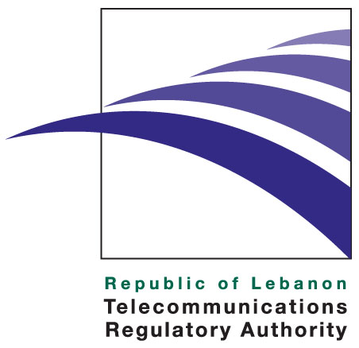

Press release

30 October 2009

In his keynote speech on “The role of TRA in the introduction of IPv6 Introduction in Lebanon” and delivered at the closing of Middle East Network Operator’s Group, MENOG 5, Dr. Kamal Shehadi, Chairman & CEO of the Telecommunications Regulatory Authority stressed the importance of the transition to IPv6. Dr. Shehadi stated that “it is needed because IPv4 addresses will be exhausted by 2011/2012 time frame mainly as a result of increased demand for new addresses for Wireless Internet and Broadband services and new converged services.” He also highlighted the fact that IPv6 adoption is inevitable and that the Government of Lebanon, ISPs, DSPs, the Ministry of Telecommunications and other concerned stakeholders must take the initiative to prepare a roadmap for IPv6 migration and make it a priority in all ICT initiatives and projects.

Dr. Shehadi outlined the technical, financial and policy challenges that IPv6 presents to the Lebanese telecom industry, stating that, the TRA will urge the Government of Lebanon to lead by example and that it will act as a facilitator to support industry measures to adopt IPv6. He highlighted the need for the private sector to collaborate in preparing an IPv6 roadmap and emphasized the TRA’s role in facilitating policy initiatives such as those related to national security or promoting IPv6 adoption in the public sector and lobbying for the required endorsement.

Finally, Dr. Shehadi reiterated the TRA’s commitment to liberalizing the international and national broadband market in Lebanon. Dr. Shehadi identified the TRA objective as enabling Lebanon to reclaim a leading role in the region as well as internationally in broadband telecommunications. The TRA recognizes that the best regulations alone are not enough and that the success of broadband liberalization depends, in large part, on GOL policy initiatives to stimulate public demand for broadband, remove any limitations on technology (such as choice of access technology, limiting mobility, etc.), and the issuance of decrees related to Rights of Way and access to Public Properties, and Spectrum Right to Use Fees. To this end, the TRA has drafted the required decrees and finished the preparations needed to launch the broadband auction of the national broadband and carrier licenses (NBCLs) and is ready to proceed forward with the Broadband strategy.

About the TRA

The TRA is an independent public institution assigned to liberalize, regulate, and develop the telecommunications sector in Lebanon. Established by Law 431 of 2002, the TRA effectively started operations upon the nomination of its board members in February 2007.

The TRA duties and powers include, among other areas, protecting consumers’ rights, licenses and regulations, managing radio spectrum and the overall numbering plan, monitoring the market for any abuse of dominant market power and anti-competitive practices, as well as taking remedial steps when needed and promoting effective and fair competition among existing and new licensed operators. More information regarding the TRA can be viewed at http://www.tra.gov.lb

Media Contact: media@tra.gov.lb

