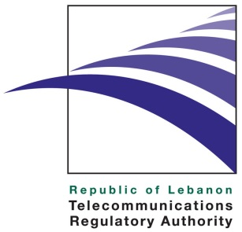
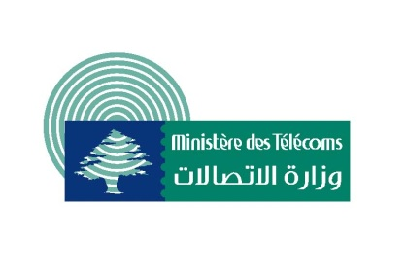

Recommendations of the
“ICT & Road Safety” Workshop
Organized by the Telecommunications Regulatory Authority & The Ministry of Telecommunications.
October 18, 2013

The first axis: Develop policies that take into account ICT standards to enhance road safety and develop Intelligent Systems to improve road safety.

- Implement the laws in force by the Internal Security Forces and issue related implementation procedures and decrees. Establish the National Council for Traffic Safety, the National Committee for Traffic Safety, the Traffic Unit and the Security Forces Training Institute mentioned in the Traffic law .
(Train the Internal Security Forces members in the framework of the establishment of the Security Forces Training Institute that was mentioned in the new traffic law)
- Collect and provide information and statistics about road accidents to be able to assess the magnitude of the problem, and develop tools to facilitate the collection of the required information.
(Role of stakeholders including the Ministry of Telecommunications and the Ministry of Justice and the Internal Security Forces in determining the number and the causes of accidents: straying cases related to the use of mobile phones)
- Issue a circular by the Ministry of Justice to all Public Prosecutions within the applicable laws granting permission to investigators to communicate with mobile companies to access the driver’s cell phone data and hold it for investigation.
- Develop and implement road design solutions such as road shoulders, pedestrian walkways, road signals and alerts, etc.
- Develop and implement technical solutions to limit cell phone use while driving such as phone shutdown applications (be it automatic or optional solutions).
- Develop safety standards for newly imported cars or locally equipped cars in line with international safety standards
The second axis:
Raise awareness among mobile phone users about road safety

- Increase media campaigns in cooperation with non-profit associations and secure the necessary funding
- Appoint a public figure to be the ambassador of telecommunications for humanitarian causes in order to raise awareness and improve education
- Increase public awareness by requesting resellers (mobile and mobile lines) to help in spreading awareness (distribute awareness brochures…)
- Create awareness among youth and children through awareness campaigns in schools, high schools and universities.
- Encourage Corporate Social Responsibilities (CSR) in public and private institutions especially those that have transportation Fleets and rely on road transportation as a core part of their work (the Army, the Internal Security Forces , Alfa, MTC , Sukleen . ..)
- Include road safety questions in the driving license test.
- Establish institutes for driving instructors and road accidents investigators to increase professional awareness regarding public safety and straying consequences.
The third axis:
Harmonization of the 79GHz frequency for radiolocation

- Support global harmonization for ITS Collision Avoidance Radar operating in the 77 to 81 GHz band
- Follow up on technical studies that will lead to a supporting position on this primary allocation to the radiolocation service in the 77.5-78 GHz frequency band for automotive applications as soon as possible.
- Stimulate the adoption of Intelligent Transport Systems in Lebanon, which will require more cooperation between the TRA and stakeholders such as car industry representatives, relevant ministries and road safety NGOs.
- Implement regulations by applying technical specifications through type approval procedures for cars equipped with short range radars systems.

- Publish the recommendations on social networking platforms and on the websites of the Ministry of Telecommunications and the Telecommunications Regulatory Authority as well as the websites of all stakeholders who participated in the workshop.
- Request from His Excellency the Minister of Telecommunications to coordinate with the Ministers of Interior, Education, Justice and the media to publish these recommendations and work on their implementation..

